**HOMEWORK II (Part 1) Report**

Contents

Summary 2

P1.1 Block Diagram 3

P1.2 Pre-simulated Waveforms 3

top_tb screenshots 3

top_tb1 screenshots 5

top_tb2 screenshots 8

P1.3 nLint check 11

P2.1Block Diagram 12

P2.2 Pre-simulated Waveforms 12

top_tb screenshots 12

top_tb1 screenshots 15

top_tb2 screenshots 18

P2.3 nLint check 21

P3.1 Block diagram 22

P3.2 Pre-simulated Waveforms 22

tb result 22

tb1 result 22

tb2 result 22

P3.3 nLint check 23

P4.1 Block Diagram 24

P4.2 Pre-simulated Waveforms 24

Rom controller 24

Load instruction to IM from MEMORY 24

Read instructions from IM 25

tb result 25

tb1 result 25

tb2 result 25

P4.3 nLint check 25

# Summary

What has been done:

* RTL level design
* Pre-synthesis simulation
* nLint check

Required tools:

* NC-Verilog, Debussy (nTrace & nWave), Design Compiler(dv), nLint
* Icarus Verilog (iverilog), gtkwave, MS visio

Stuck:

* ROM/MEMORY time delay
* Control ir_controller and mem_controller by rom_controller
* Design loading instructions from IM to MEMORY
* Handle time delay in testbench

# P1.1 Block Diagram

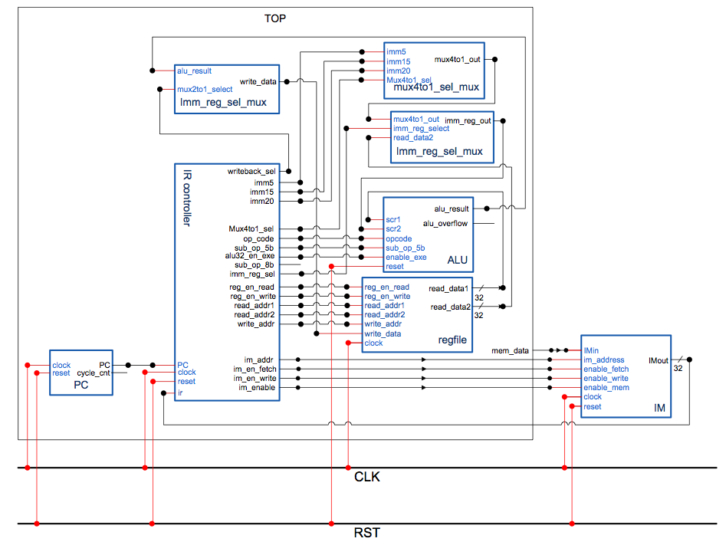

# P1.2 Pre-simulated Waveforms

## top_tb screenshots

* Test: load 13 instructions(Fig.1-2) to IM

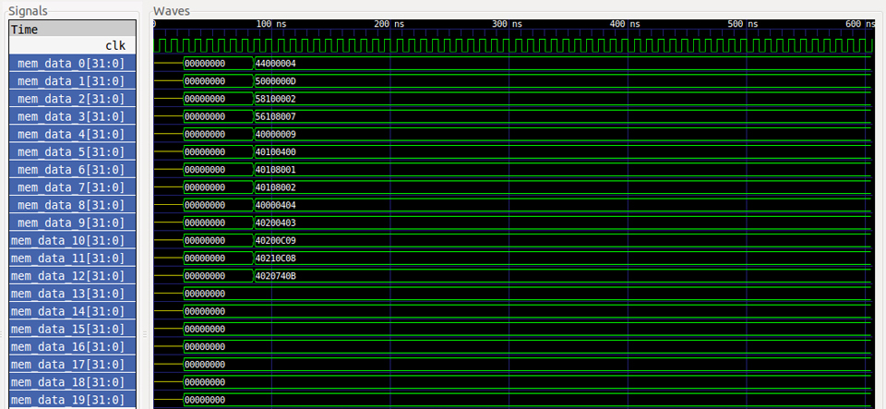

* Test 1(marked in red block): MOVI (R0=20'd4)
* Test 2(marked in blue block):ADDI (R0=R0+4'b1101)
* Test 3(marked in yellow block): ORI (R1=R0|4'b0010)

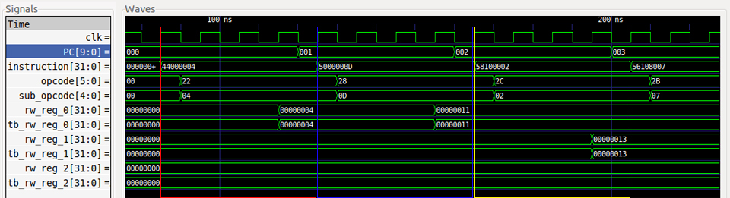

* Test 4(marked in red block): XORI (R1=R1^4'b0111)
* Test 5(marked in blue block): NOP
* Test 6(marked in yellow block): ADD R1=R0+R1

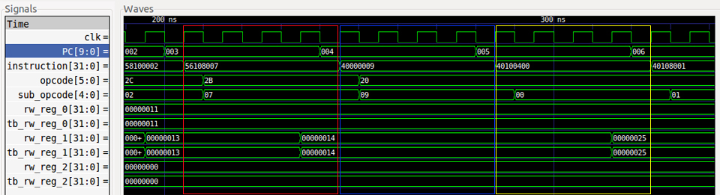

* Test 7(marked in red block): XORI (SUB R1=R1-R0)
* Test 8(marked in blue block): AND (R1=R1&R0)
* Test 9(marked in yellow block): OR (R0=R0|R1)

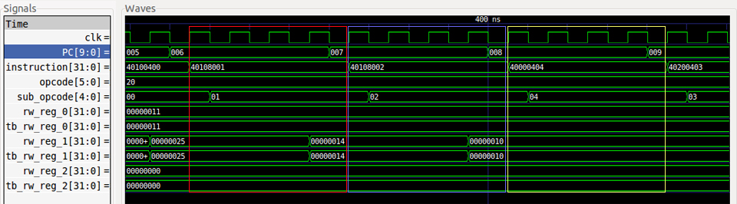

* Test 10(marked in red block): XOR (R2=R0^R1)
* Test 11(marked in blue block): SRLI (R2=R0 SRL(3))
* Test 12(marked in yellow block): SLLI (R2=R2 SLL(3))

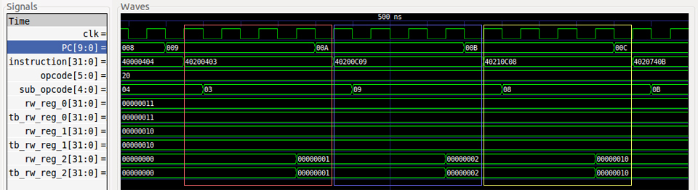

* Test 13(marked in yellow block): ROTRI (R2=R0 ROTR(29))

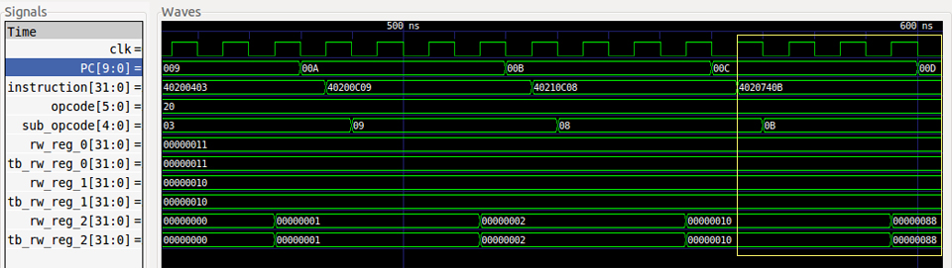

## top_tb1 screenshots

* Test: load 20 instructions to IM

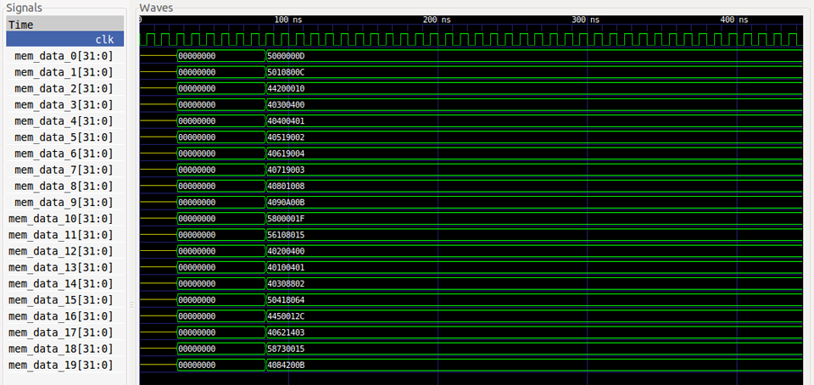

* Test 1(marked in red block): ADDI (R0=R0+5’b01101)
* Test 2(marked in yellow block): ADDI (R1=R1+5’b01100)

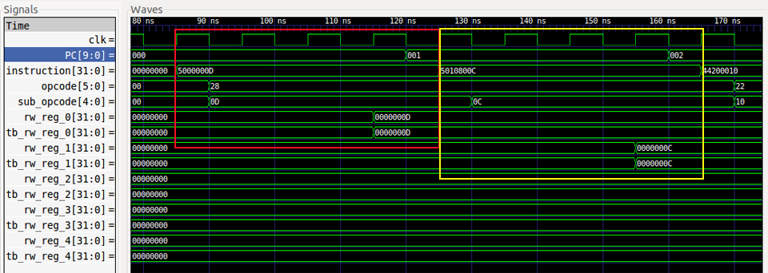

* Test 3(marked in red block): MOVI (R2= 5’b01000)
* Test 4(marked in yellow block): ADD (R3=R0+R1)

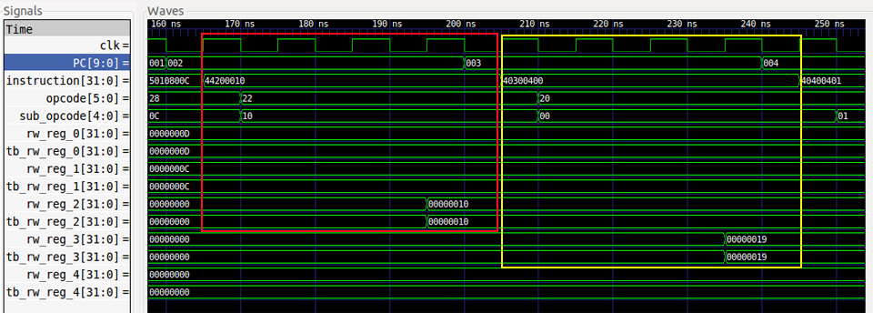

* Test 5(marked in red block): SUB (R4=R0-R1)
* Test 6(marked in yellow block): AND (R5=R3&R4)

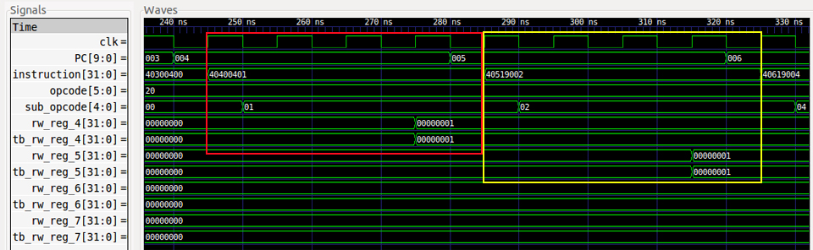

* Test 7(marked in red block): OR (R6=R3|R4)
* Test 8(marked in yellow block): XOR (R7= R3^R4)

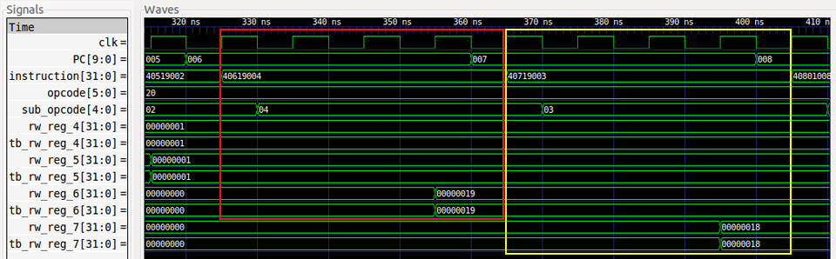

* Test 9(marked in red block): SLLI (R8=R0<<5’b00100)
* Test 10(marked in yellow block): ROTRI (R9=R1>>5’b01000)

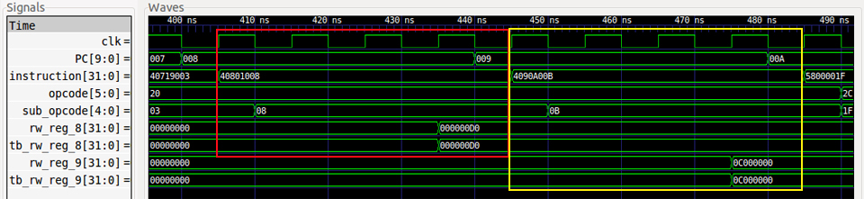

* Test 11(marked in red block): ORI (R0=R0|5’b11111)
* Test 12(marked in yellow block): XORI (R1=R1+5’b10101)

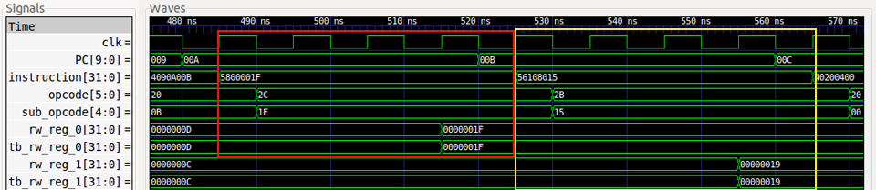

* Test 13(marked in red block): ADD (R2=R0+R1)
* Test 14(marked in yellow block): SUB (R1=R0-R1)

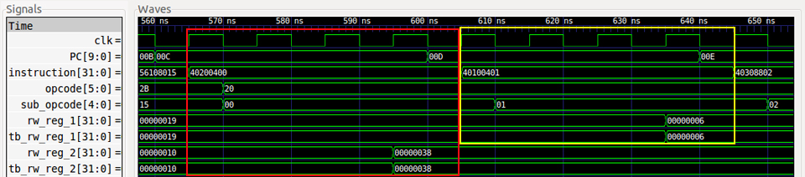

* Test 15(marked in red block): AND (R3=R1&R2)
* Test 16(marked in yellow block): ADDI (R4=R3+’d100)

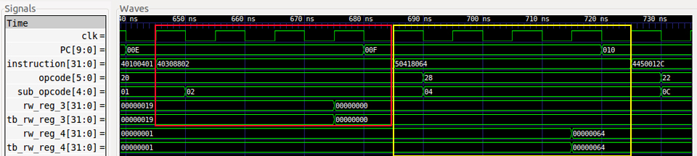

* Test 17(marked in red block): MOVI (R5=’d300)
* Test 18(marked in yellow block): XOR (R6=R4^R5)

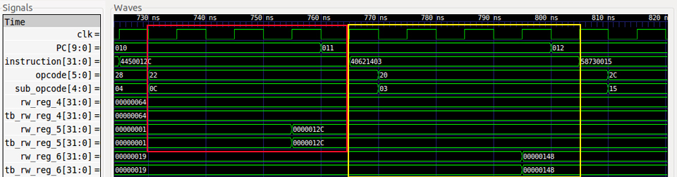

* Test 19(marked in red block): ORI (R7=R6|5’b10101)
* Test 20(marked in yellow block): ROTRI (R8=R8 ROTR(5’b01000) )

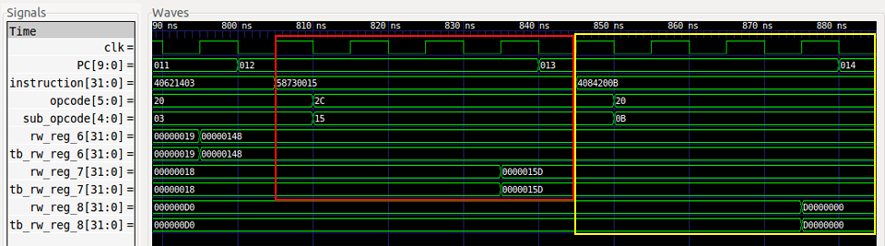

## top_tb2 screenshots

* Test: load 20 instructions to IM

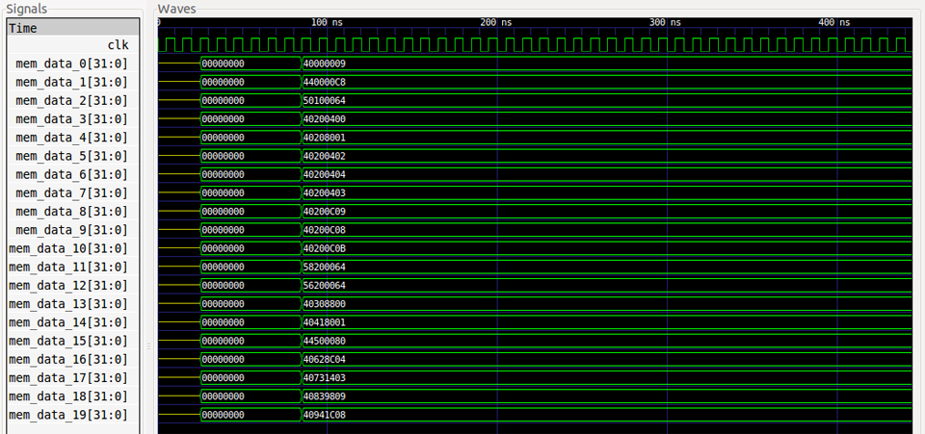

* Test 1(marked in red block): NOP
* Test 2(marked in yellow block): MOVI (R0=’d200)

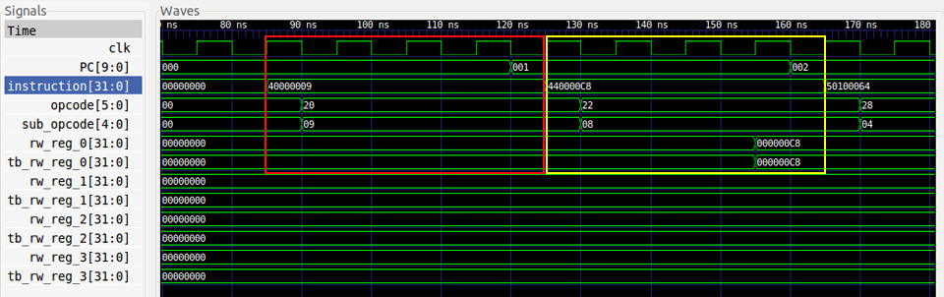

* Test 3(marked in red block): ADDI (R1=R0+’d100)
* Test 4(marked in yellow block): ADD (R2=R0+R1)

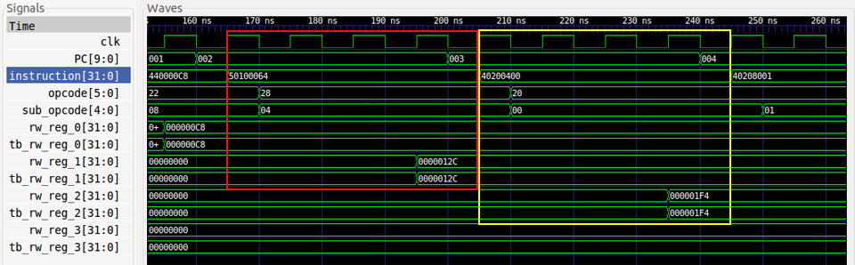

* Test 5(marked in red block): SUB (R2= R1-R0)
* Test 6(marked in yellow block): AND (R2=R0&R1)

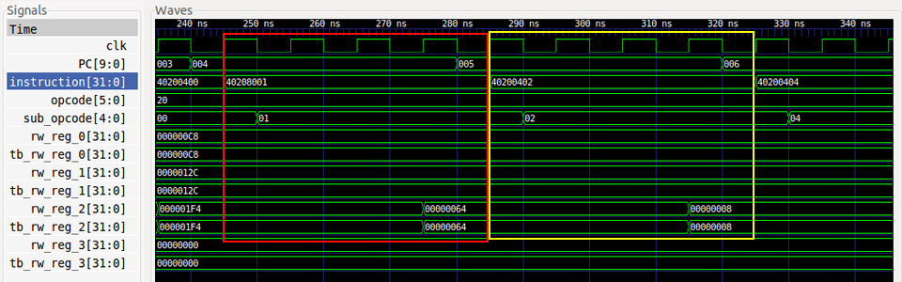

* Test 7(marked in red block): OR (R2=R0|R1)
* Test 8(marked in yellow block): XOR (R2=R0^R1)

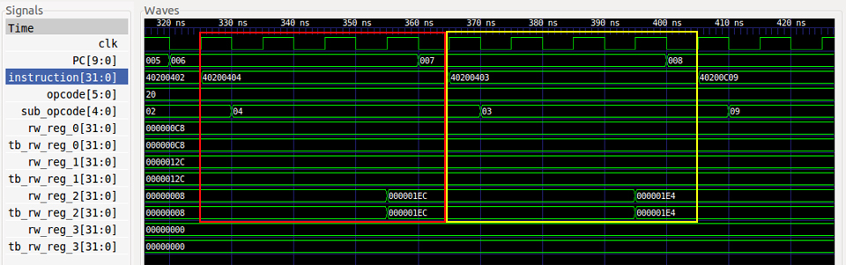

* Test 9(marked in red block): SRLI (R2=R0>>’d3)
* Test 10(marked in yellow block): SLLI (R2=R0<<’d3)

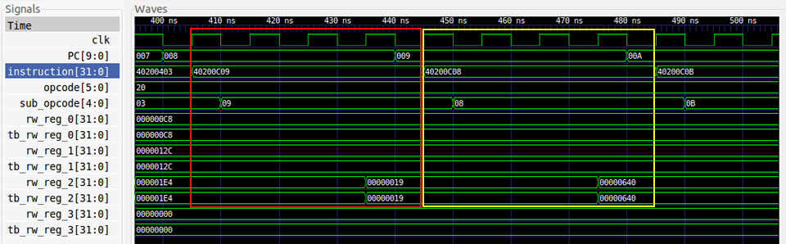

* Test 11(marked in red block): ROTRI (R2=R0 ROTR(3))
* Test 12(marked in yellow block): ORI (R2=R0 |’d100)

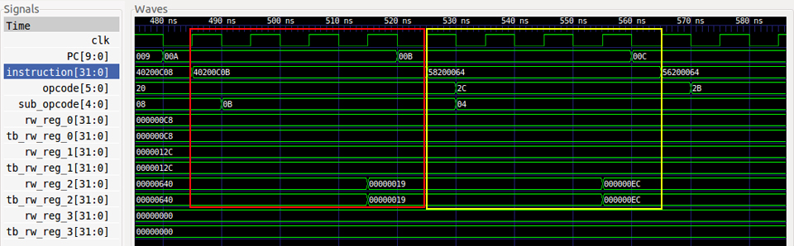

* Test 13(marked in red block): XORI (R2=R0^’d100)
* Test 14(marked in yellow block): ADD (R3=R1+R2)

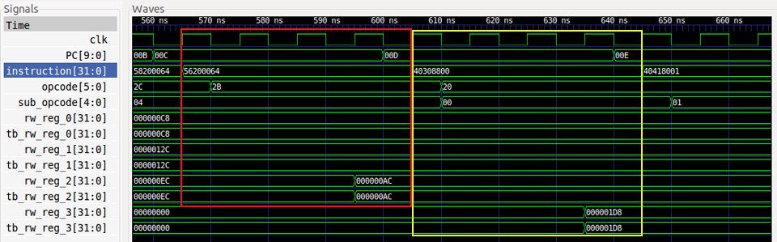

* Test 15(marked in red block): SUB (R4=R3-R0)
* Test 16(marked in yellow block): MOVI (R5=’d128)

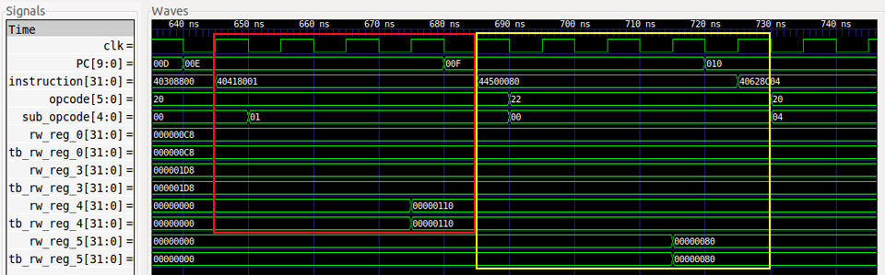

* Test 17(marked in red block): OR (R6=R5|R3)
* Test 18(marked in yellow block): XOR (R7=R6^R5)

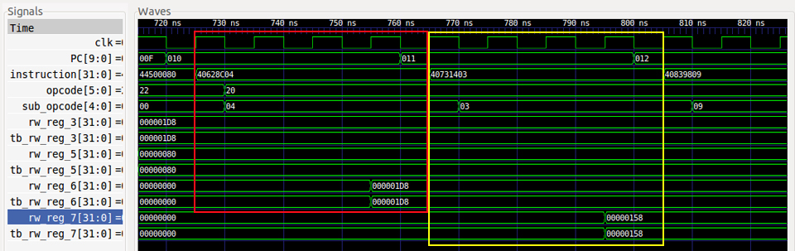

* Test 19(marked in red block): SRLI (R8=R7>>’d6)
* Test 20(marked in yellow block): SLLI (R9=R8<<’d7)

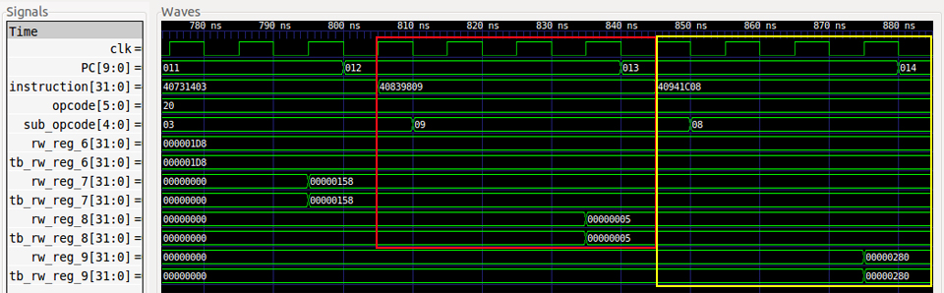

# P1.3 nLint check

9 Warning(S), 6 Erros(s) in 1062 Line(s) => 98%

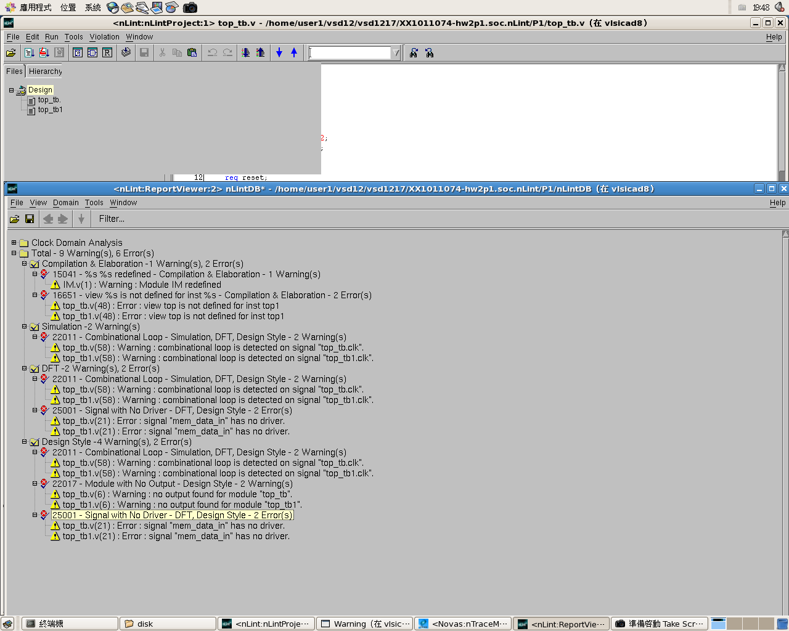

# P2.1Block Diagram

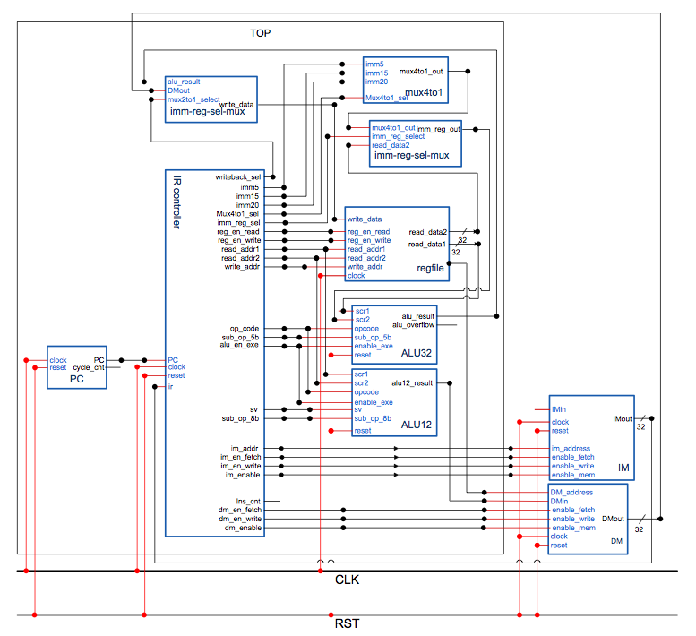

# P2.2 Pre-simulated Waveforms

## top_tb screenshots

* Test: load 17 instructions(Fig.2-2) to IM and prepare DM

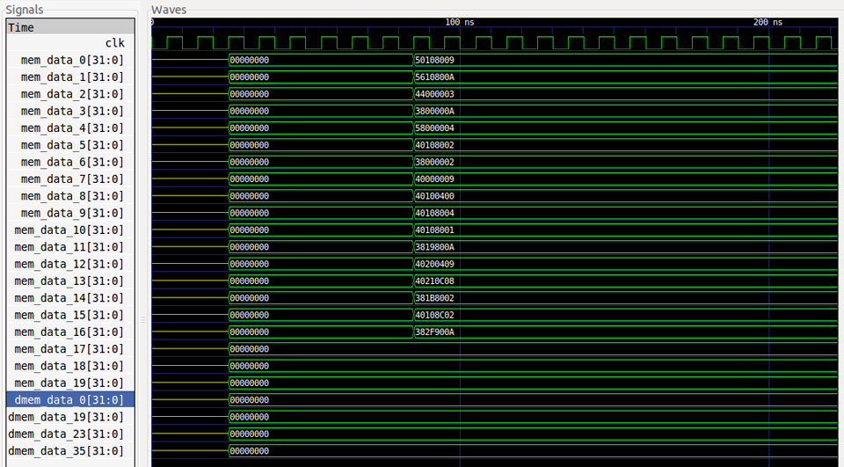

* Test 1(marked in red block): ADDI (R1=R1+4'b1001)
* Test 2(marked in yellow block): XORI (R1=R1^4'b1010)

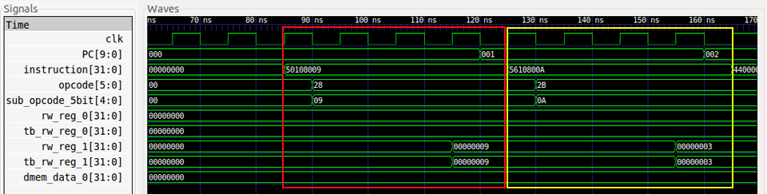

* Test 3(marked in red block): MOVI (R0=20'd3)
* Test 4(marked in yellow block): SW (M0=R0)

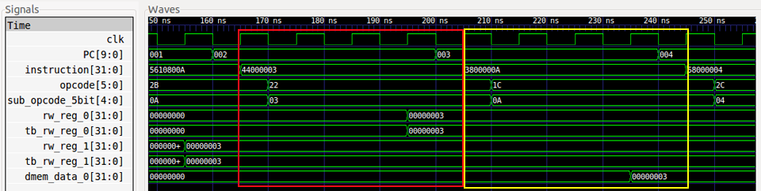

* Test 5(marked in red block): ORI (R0=R0|4'b0100)
* Test 6(marked in yellow block): AND (R1=R1&R0)

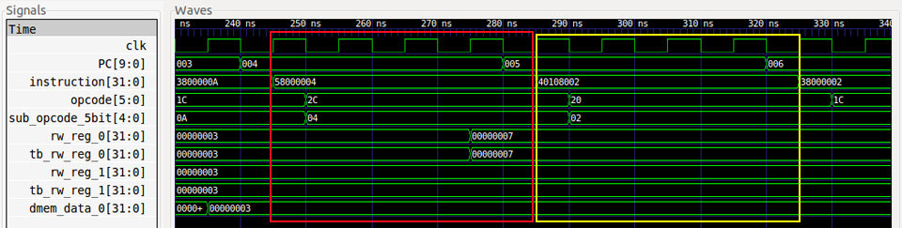

* Test 7(marked in red block): LW (R0=M0)
* Test 8(marked in yellow block): NOP

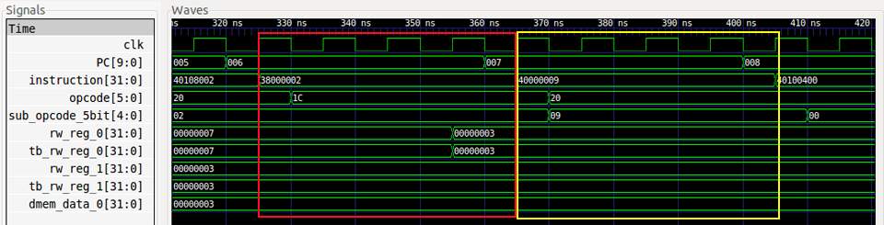

* Test 9(marked in red block): ADD (R1=R0+R1)
* Test 10(marked in yellow block): OR (R1=R1|R0)

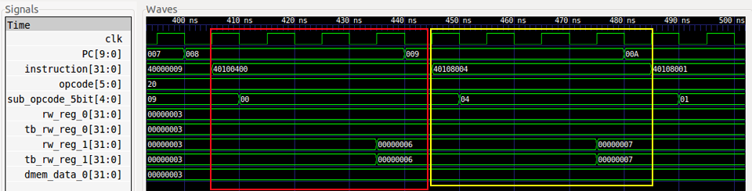

* Test 11(marked in red block): SUB (R1=R1-R0)
* Test 12(marked in yellow block): SW (M19=R1)

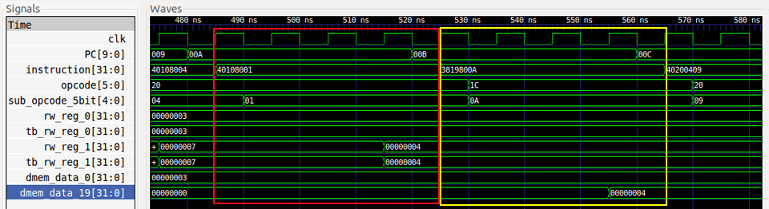

* Test 13(marked in red block): SRLI (R2=R0 SRL(‘d1) )
* Test 14(marked in yellow block): SLLI (R2=R2 SLL(‘d3) )

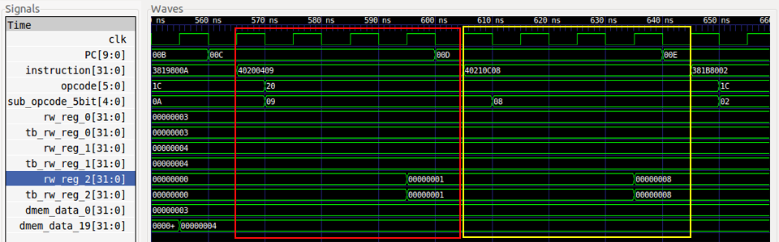

* Test 15(marked in red block): LW (R1=M23)
* Test 16(marked in yellow block): AND (R1=R1&R3)

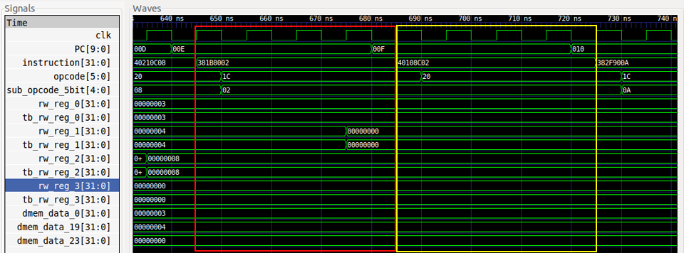

* Test 17(marked in yellow block): SW (M35=R2)

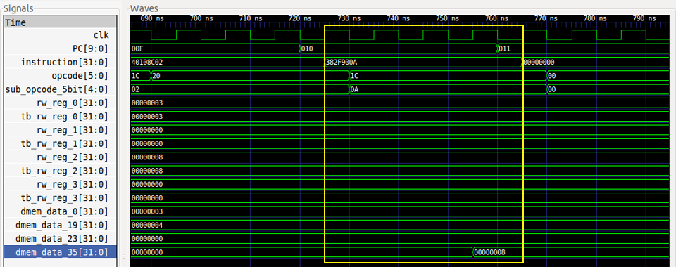

## top_tb1 screenshots

* Test: load 22 instructions to IM and prepare DM

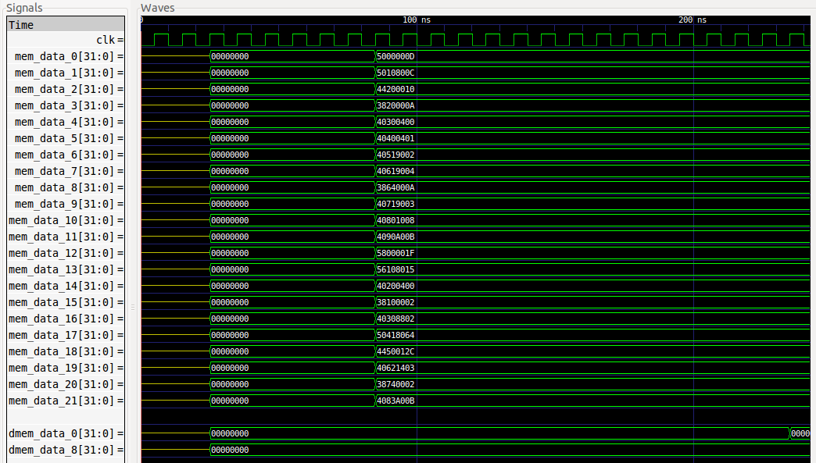

* Test 1(marked in red block): ADDI (R0=R0+5’b01101)
* Test 2(marked in yellow block): ADDI (R1=R1+5’b01100)

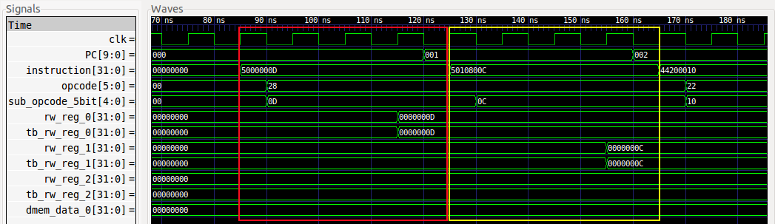

* Test 3(marked in red block): MOVI (R2= 5’b01000)
* Test 4(marked in yellow block): SW (M0=R2)

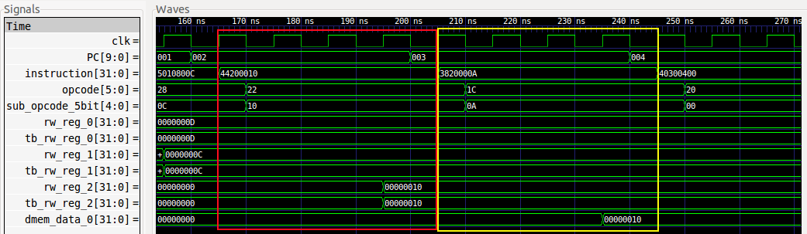

* Test 5(marked in red block): ADD (R3=R0+R1)
* Test 6(marked in yellow block): SUB (R4=R0-R1)

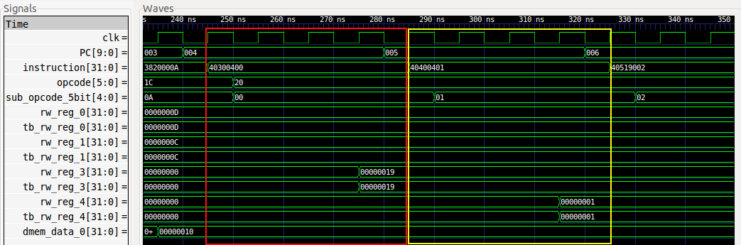

* Test 7(marked in red block): AND (R5=R3&R4)
* Test 8(marked in yellow block): OR (R6=R3|R4)

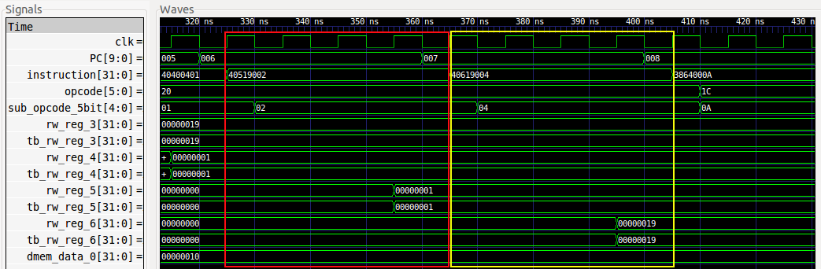

* Test 9(marked in red block): SW (M8=R6)
* Test 10(marked in yellow block): XOR (R7=R3^R4)

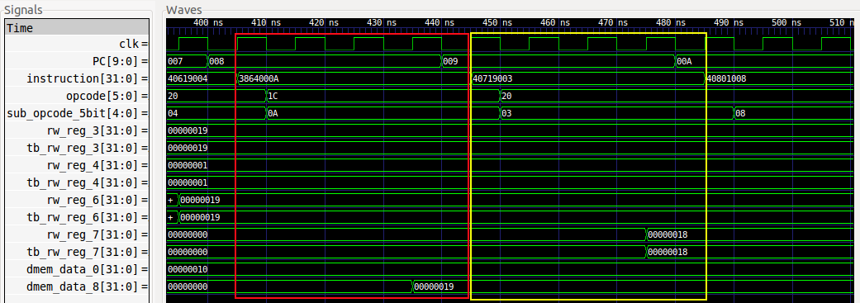

* Test 11(marked in red block): SLLI (R8=R0<<5’b00100)
* Test 12(marked in yellow block): ROTRI (R9=R1 ROT (5’b01000))

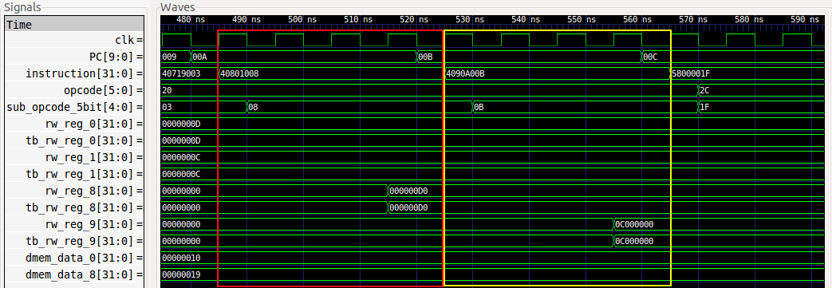

* Test 13(marked in red block): ORI (R0=R0|5’b11111)
* Test 14(marked in yellow block): XORI (R1=R1+5’b10101)

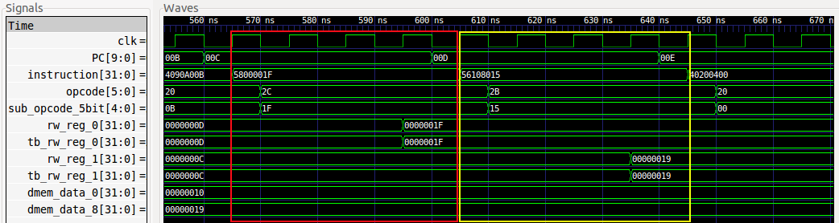

* Test 15(marked in red block): ADD (R2=R0+R1)
* Test 16(marked in yellow block): LW (R1=M0)

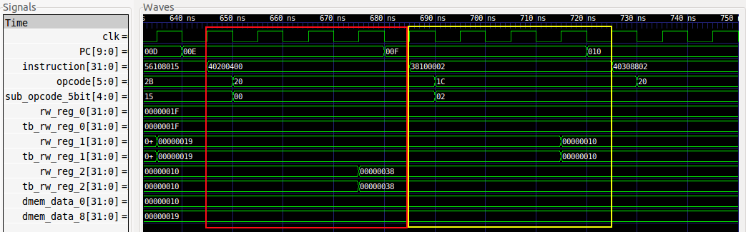

* Test 17(marked in red block): AND (R3=R1&R2)
* Test 18(marked in yellow block): ADDI (R4=R3+’d100)

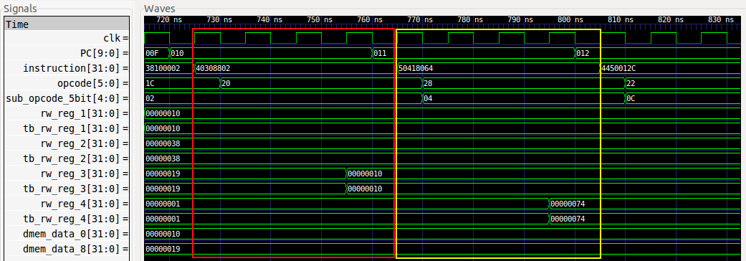

* Test 19(marked in red block): MOVI (R5=’d300)
* Test 20(marked in yellow block): XOR (R6=R4^R5)

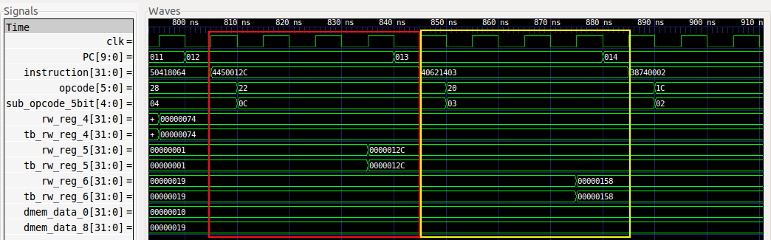

* Test 21(marked in red block): LW (R7=M8)
* Test 22(marked in yellow block): ROTRI (R8=R7 ROT (5'b01000))

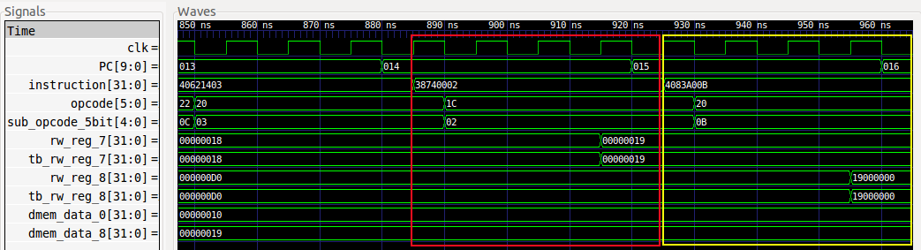

## top_tb2 screenshots

* Test: load 24 instructions to IM and prepare DM

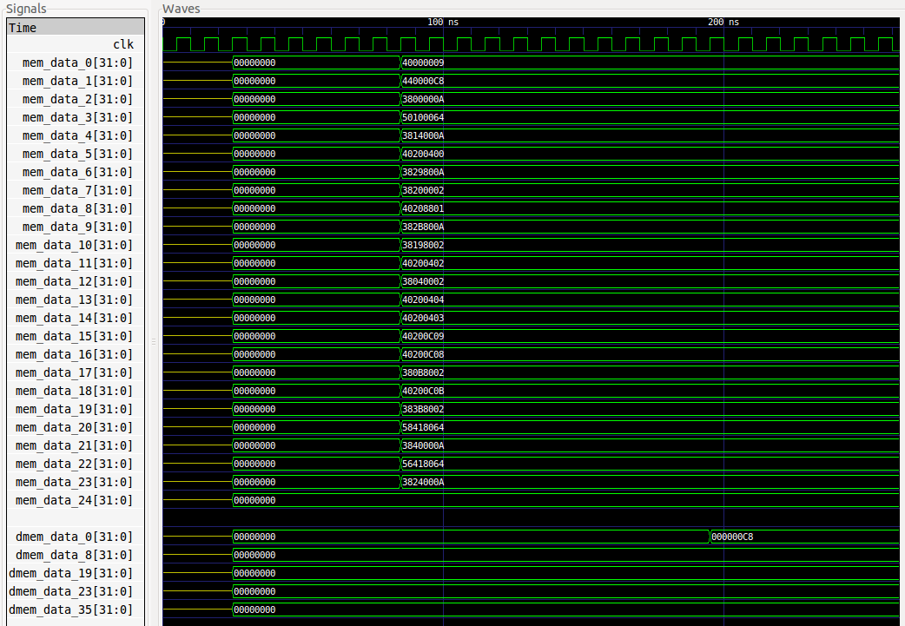

* Test 1(marked in red block): NOP
* Test 2(marked in blue block): MOVI (R0=’d200)
* Test 3(marked in yellow block): SW (M0=R0)

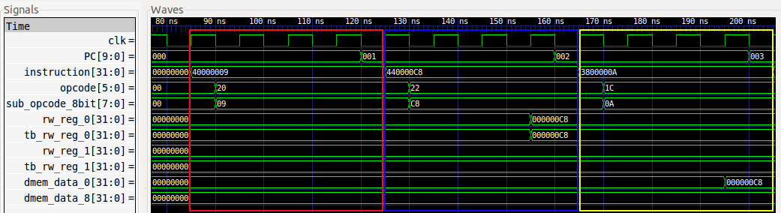

* Test 4(marked in red block): ADDI (R1=R0+’d100)
* Test 5(marked in blue block): SW (M8=R1)
* Test 6(marked in yellow block): ADD (R2=R0+R1)

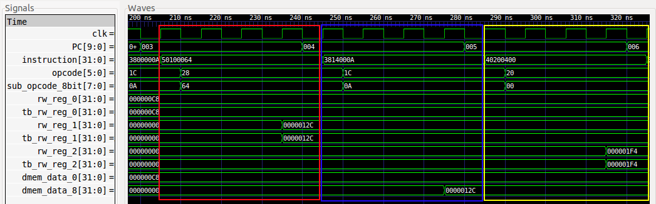

* Test 7(marked in red block): SW (M19=R2)
* Test 8(marked in blue block): LW (R2=M0)
* Test 9(marked in yellow block): SUB (R2=R2-R1)

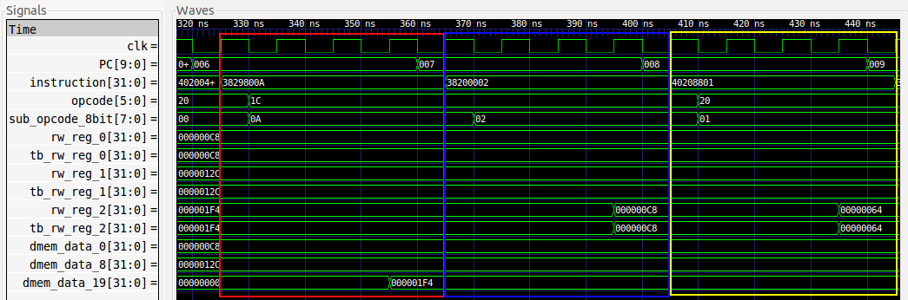

* Test 10(marked in red block): SW (M23=R2)
* Test 11(marked in blue block): LW (R1=M19)
* Test 12(marked in yellow block): AND (R2=R0&R1)

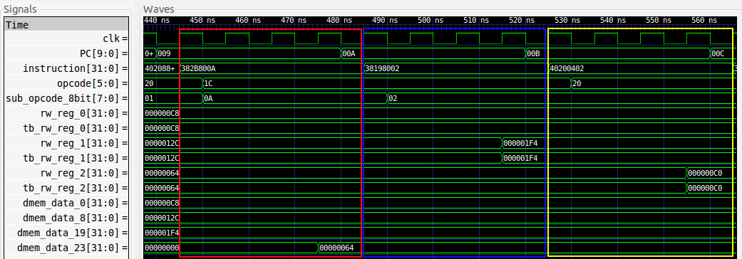

* Test 13(marked in red block): LW (R0=M8)
* Test 14(marked in blue block): OR (R2=R0|R1)
* Test 15(marked in yellow block): XOR (R2=R0^R1)

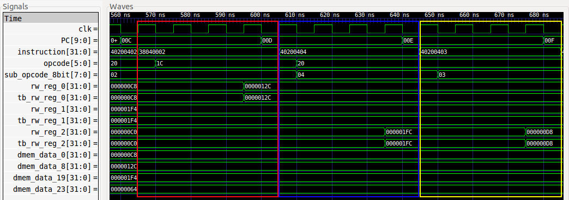

* Test 16(marked in red block): SRLI (R2=R0>>5'b00011)
* Test 17(marked in blue block): SLLI (R2=R0<<5'b00011)
* Test 18(marked in yellow block): LW (R0=M23)

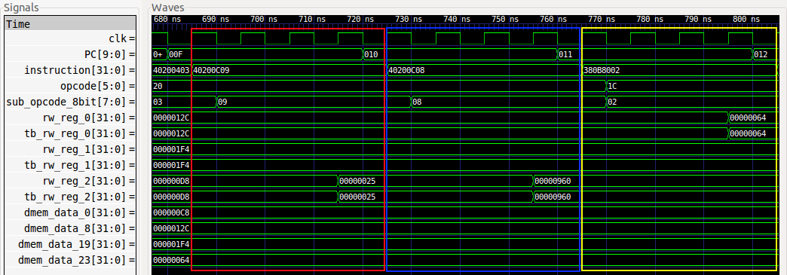

* Test 19(marked in red block): ROTRI (R2=R0 ROT (5'b00011))
* Test 20(marked in blue block): LW (R3=M23)
* Test 21(marked in yellow block): ORI (R4=R3|'d100)

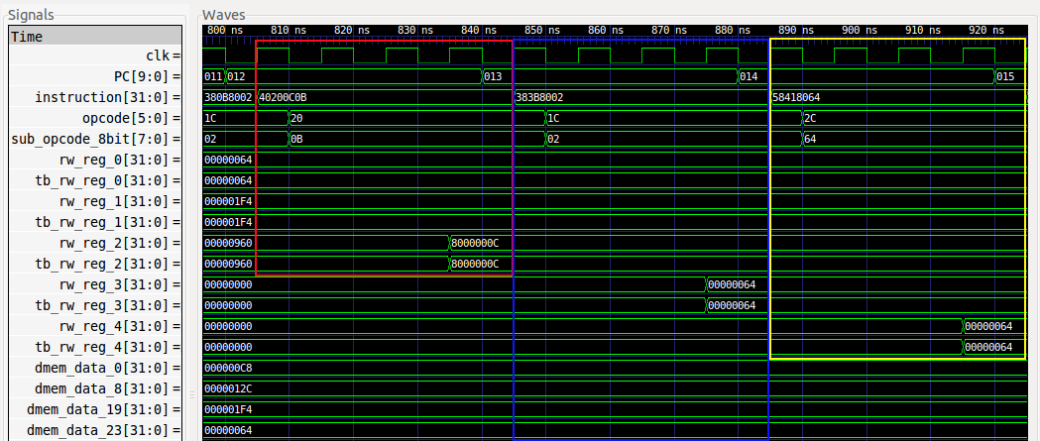

* Test 22(marked in red block): SW (M0=R4)
* Test 23(marked in blue block): XORI (R4=R3^'d100)
* Test 24(marked in yellow block): SW (M8=R2)

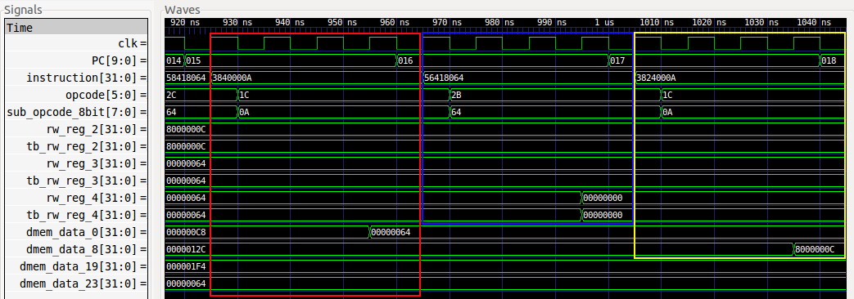

# P2.3 nLint check

52 Warning(S), 17 Erros(s) in 1514 Line(s) => 95%

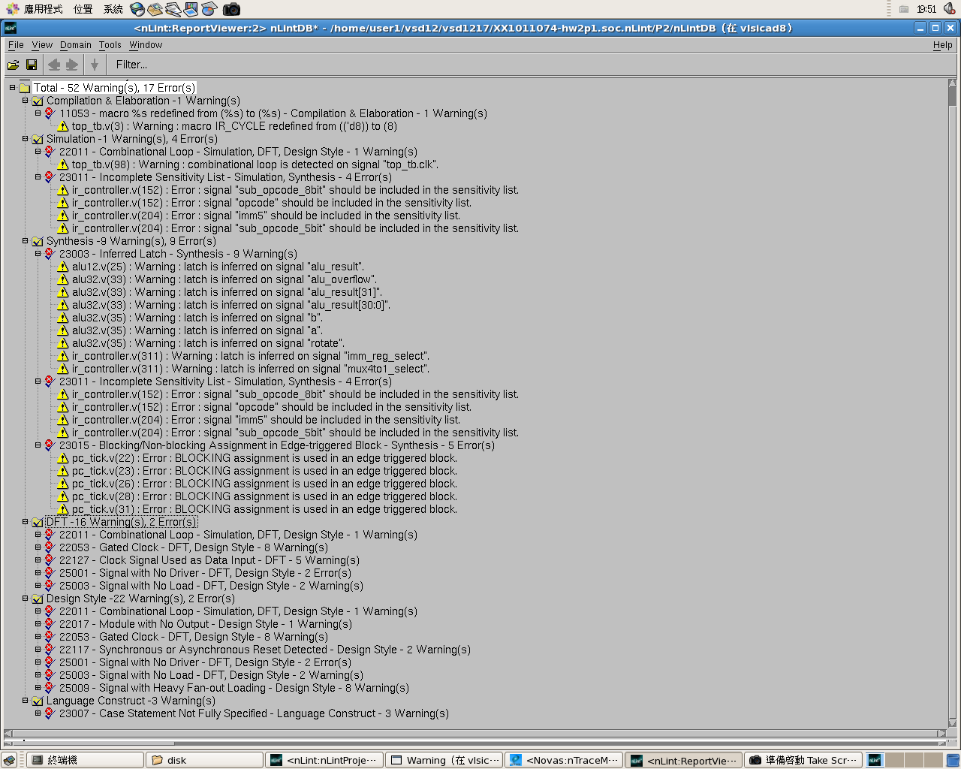

# P3.1 Block diagram



# P3.2 Pre-simulated Waveforms

## tb result

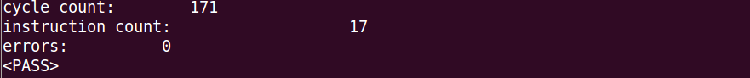

## tb1 result

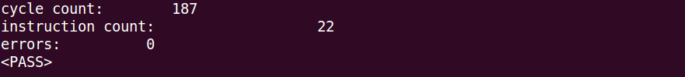

## tb2 result

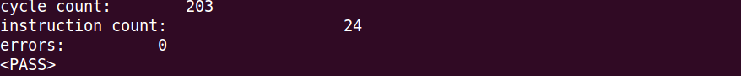

# P3.3 nLint check

59 Warning(S), 19 Erros(s) in 1564 Line(s) => 95%

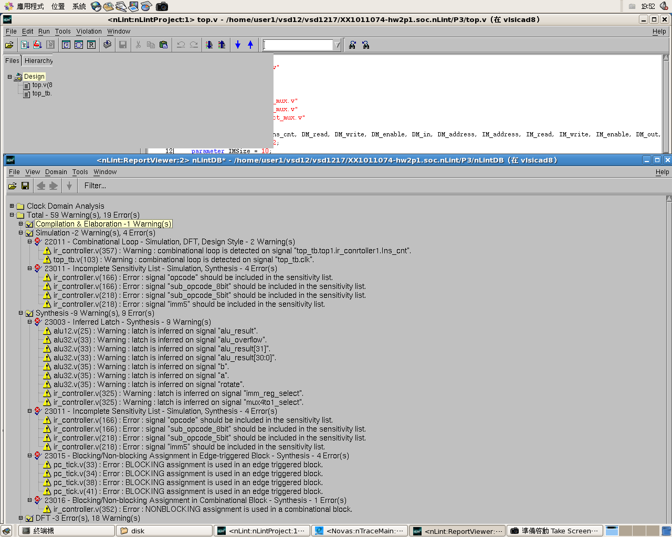

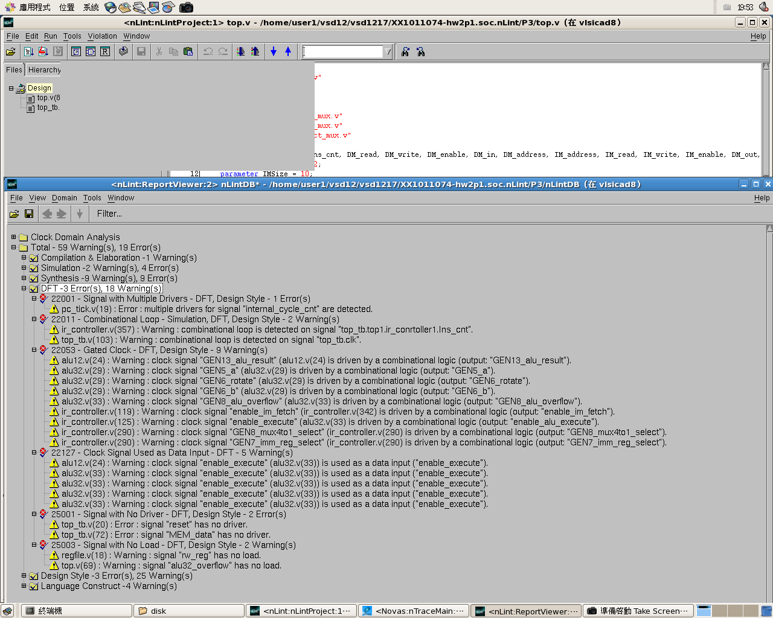

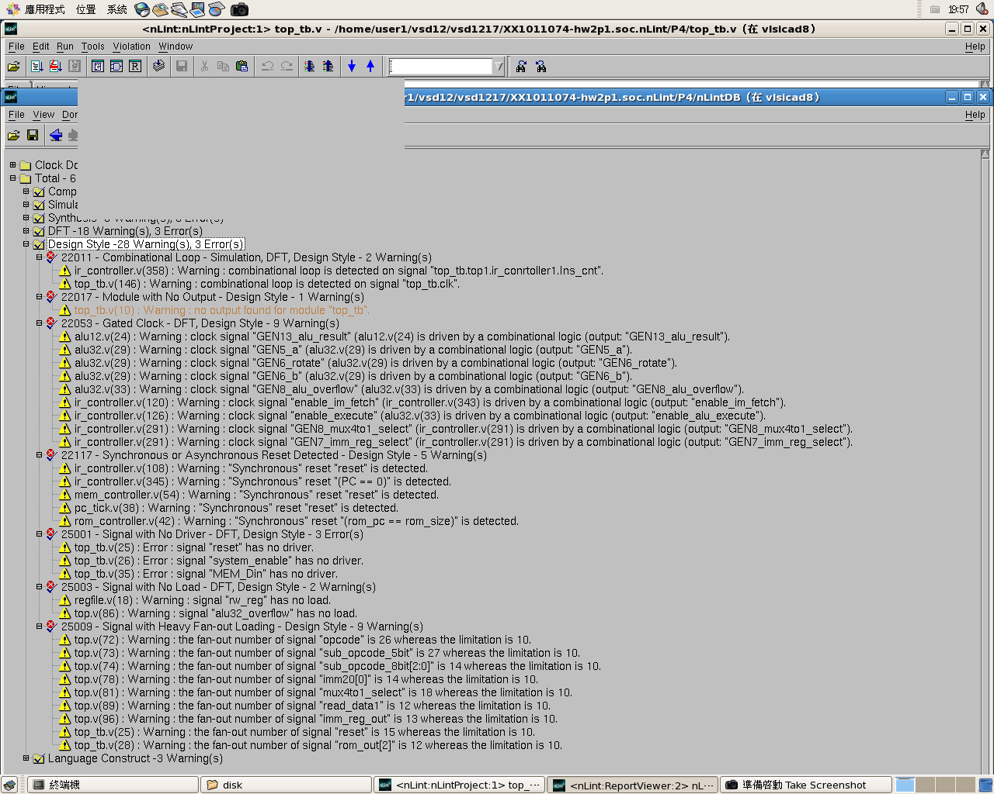

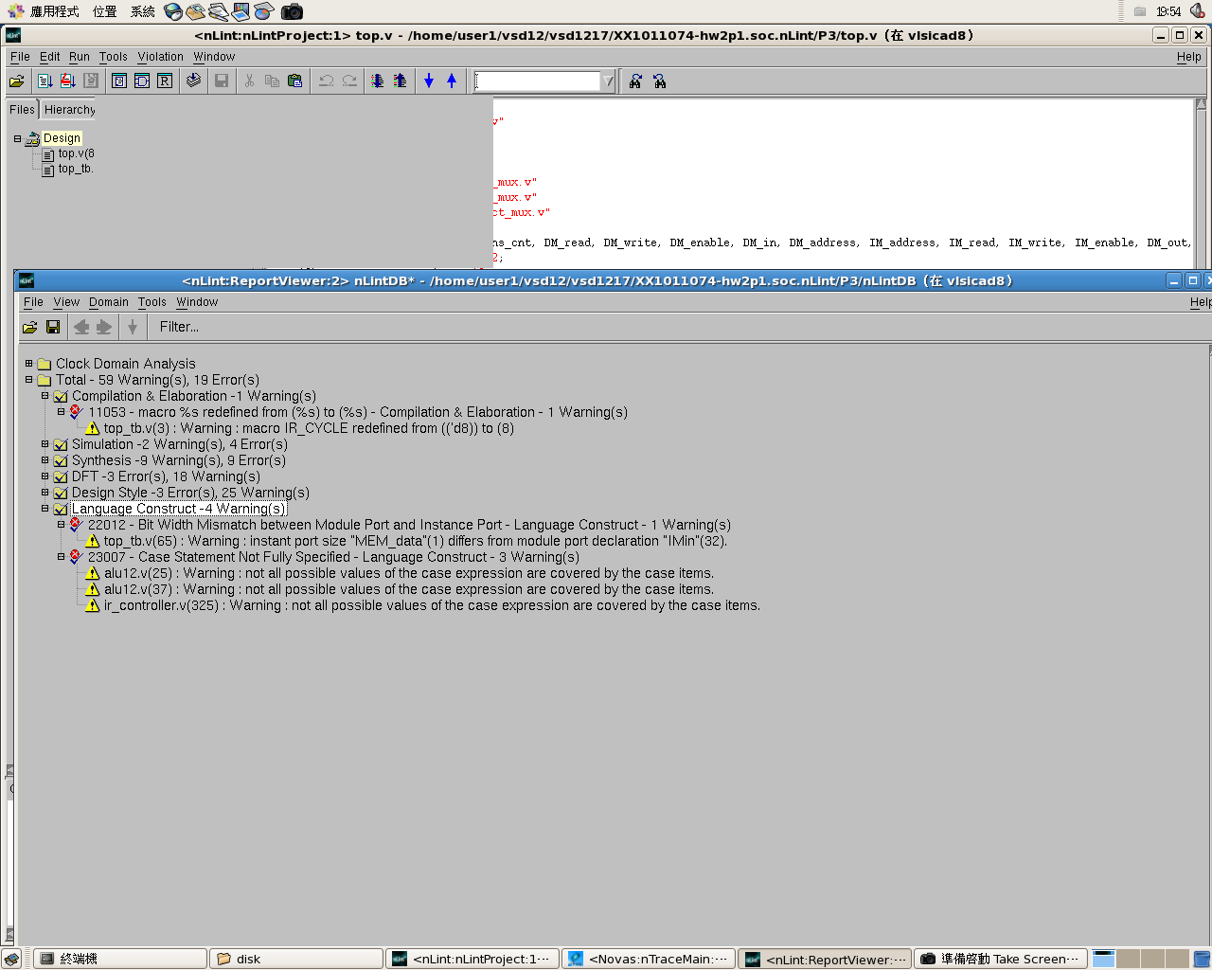

# P4.1 Block Diagram

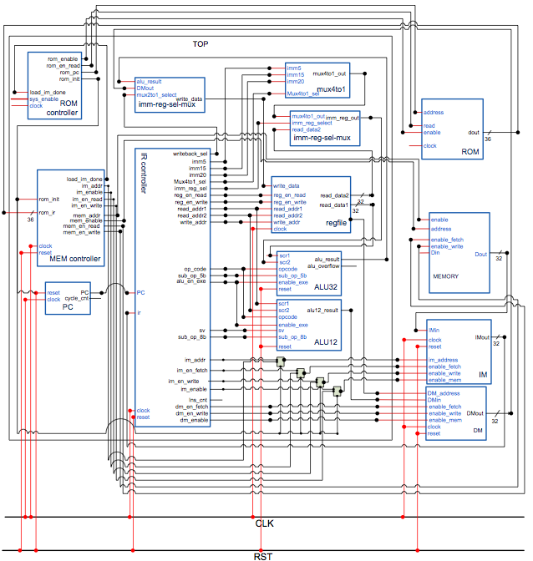

# P4.2 Pre-simulated Waveforms

## Rom controller

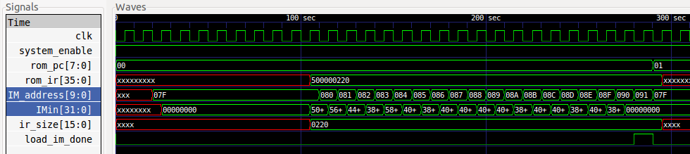

## Load instruction to IM from MEMORY

(繳交的程式中, 設錯寫入的IM位址, 由於無法用ncverilog驗證, 因此尚未更改)

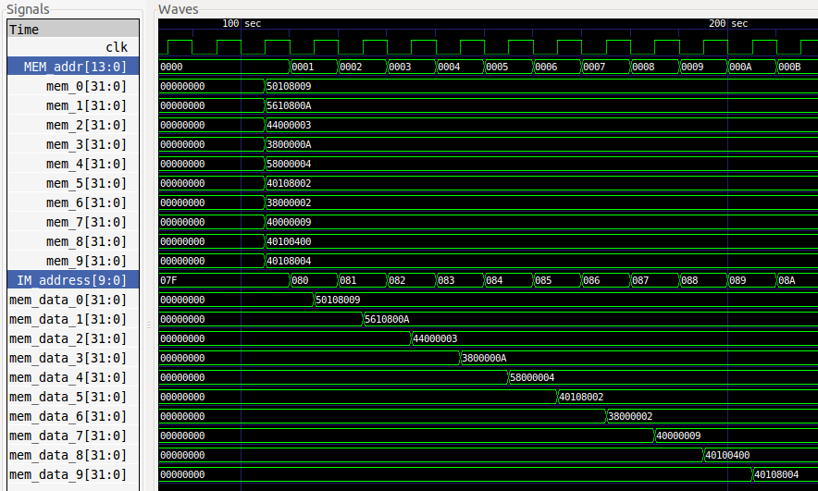

## Read instructions from IM

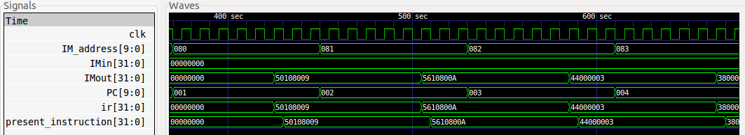

## tb result

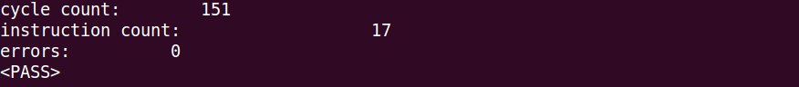

## tb1 result

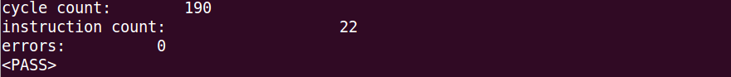

## tb2 result

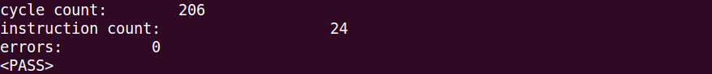

# P4.3 nLint check

61 Warning(S), 19 Erros(s) in 1944 Line(s) => 96%

